First Evidence LPR Monitor

Software Version 3.0.1
18 September, 2009

Contents

System Overview 2

System Overview
The First Evidence LPR Monitor is an application that can monitor the LPR service (either locally on the same computer or remotely over a network) and gather statistical data. When the program first starts, it automatically attempts a test connection to the loaded remote servers (and includes the local machine if no servers have been configured). Once a remote connection has been successfully made, the name of the remote system appears in the left column.
Stats selection buttons – click a button to see the associated health statistics

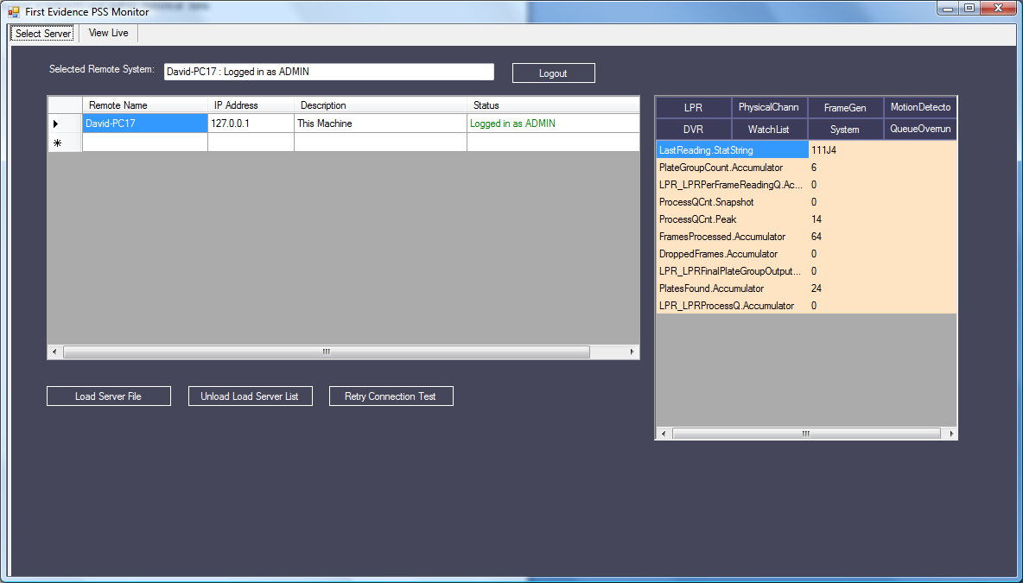
Load Server File – this button provides an option of loading a text file containing the IP addresses of remote LPR servers to monitor. By default, if this file is not loaded, the local machine is pre-loaded into the table of servers.
Unload Service list – this button allows the clearing of the previously loaded server file and table.
Adin/View login – allows logging in to a selected server. The remote system must have been detected successfully in order to get the Remote Name to appear. If the initial test connection is not successful, the service may not be running. Click the re-try Connection test to try again.
NOTE: The Remote name must be highlighted in order to login. Be sure to click on the text of the name to highlight it.
Retry Connection Test – if the remote server could not be pinged when its address was first loaded, click this button to re-try the ping and test connection.
View Live tab – allows the user to click on Play and see video from all connected cameras.

